Programming Assignment 1

**Name: Sarthak Kumar Roll Number: 160627**

Note1: Point 1, Point2 are initial points.

Note2: r and s are initial guess of coefficient of quadratic equation x^2-s*x-r;

**Sample function 1:** x-cos(x)

**Function Plot:**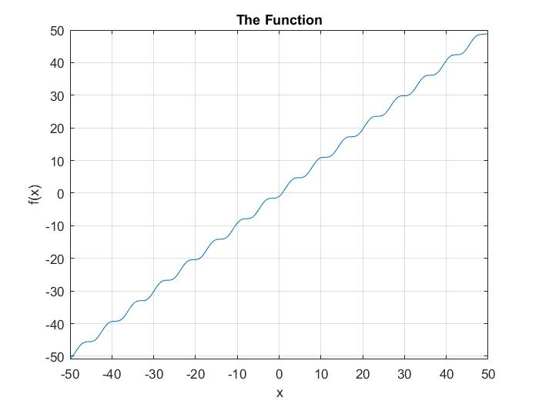

**1: Bisection**

Point 1=0

Point 2=1

Max number of iterations=50;

Criterion for Relative Error=0.0001

Criterion for closeness of function=0.00001

Root=0.739075

flag: Termination due to convergence of interval

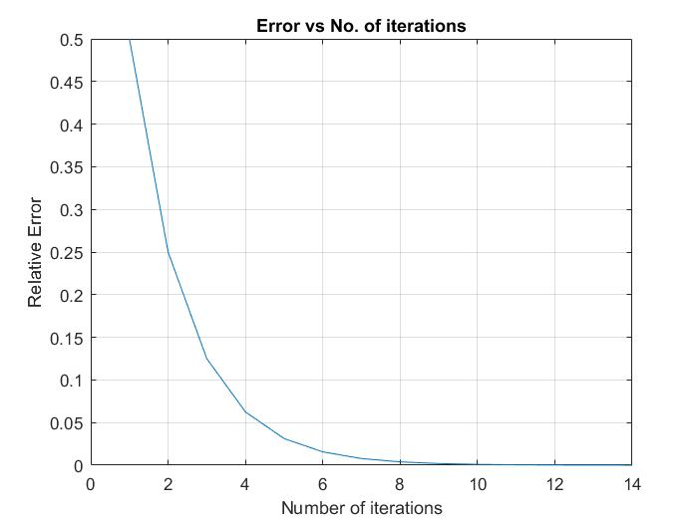

**2: False Position**

Point 1=0

Point 2=1

Max number of iterations=50;

Criterion for Relative Error=0.0001

Criterion for closeness of function=0.00001

Root=0.739085

Flag=Termination due to convergence of function value

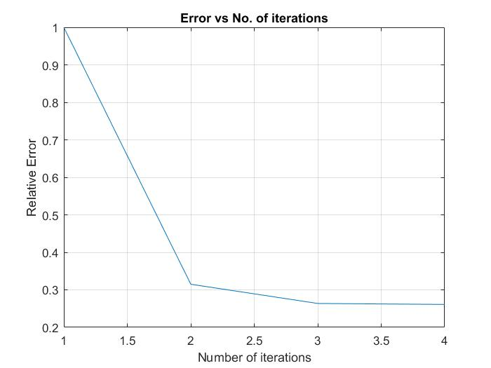

**3: Fixed Point**

g(x) = cos(x)

Point 1=0

Max number of iterations=50;

Criterion for Relative Error=0.0001

Criterion for closeness of function=0.00001

Root=0.739106

Flag=Termination due to convergence in relative approximate error

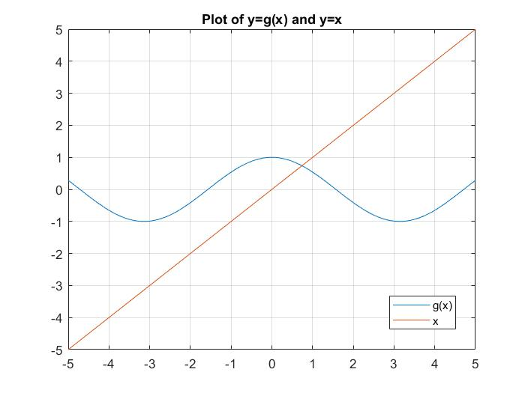

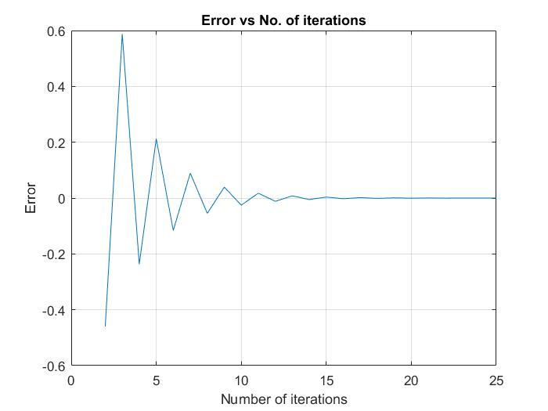  **:** **Relative error vs Number of iterations graph**

**4: Newton Raphson**

Point 1=0

Max number of iterations=50;

Criterion for Relative Error=0.0001

Criterion for closeness of function=0.00001

Root=0.739085

Flag=Termination due to convergence of relative approximate error

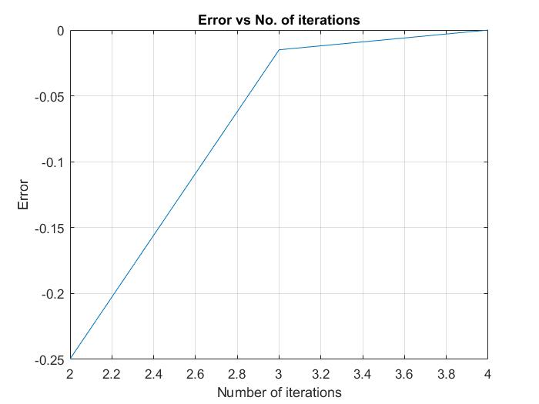

**Relative error vs Number of iterations graph**

**5: Secant Method**

Point 1=0

Point 2=1

Max number of iterations=50;

Criterion for Relative Error=0.0001

Criterion for closeness of function=0.00001

Root= 0.739085

Flag= Termination due to convergence of function value

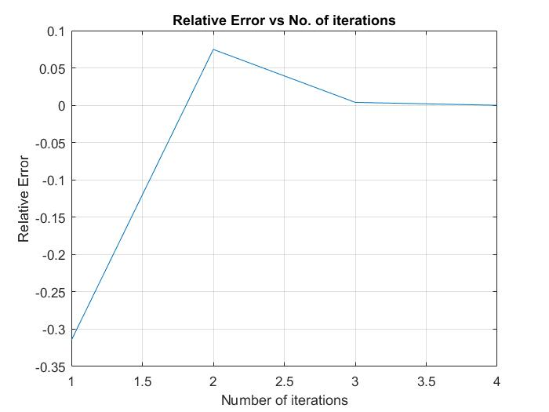

**Sample Function 2:** exp(-x)-x

**Function Plot:**

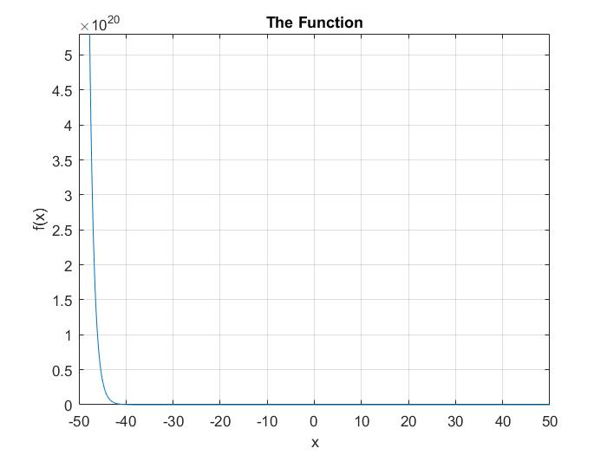

**1: Bisection**

Point 1=0

Point 2=1

Max number of iterations=50;

Criterion for Relative Error=0.0005

Criterion for closeness of function=0.00001

Root= 0.566895

Flag= Termination due to convergence of interval

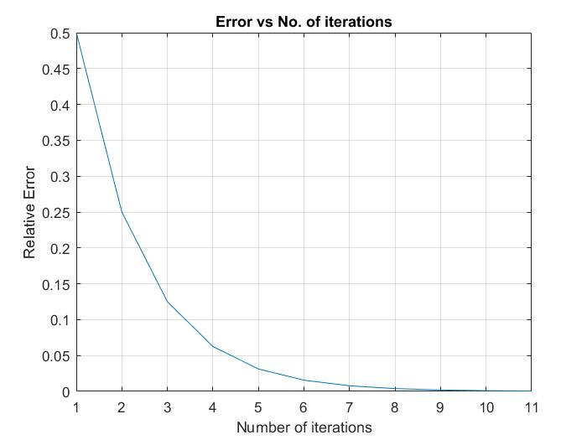

**2: False Point**

Point 1=0

Point 2=1

Max number of iterations=50;

Criterion for Relative Error=0.0005

Criterion for closeness of function=0.00001

Root: 0.567144

Flag= Termination due to convergence of function value

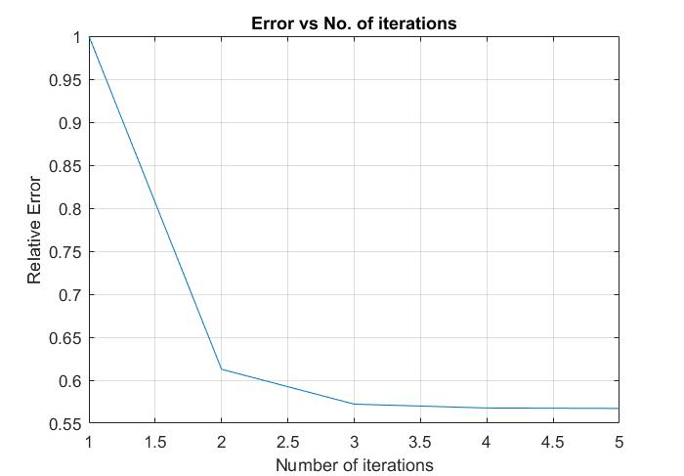

**3: Fixed Point**

g(x) = exp(-x)

Point 1=0

Max number of iterations=50;

Criterion for Relative Error=0.0005

Criterion for closeness of function=0.00001

Root = 0.567068

Flag = Termination due to convergence in relative approximate error

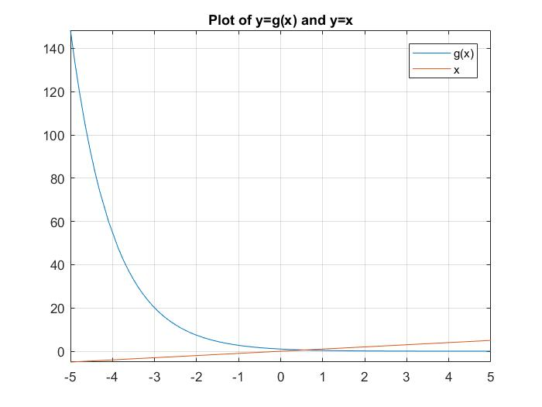

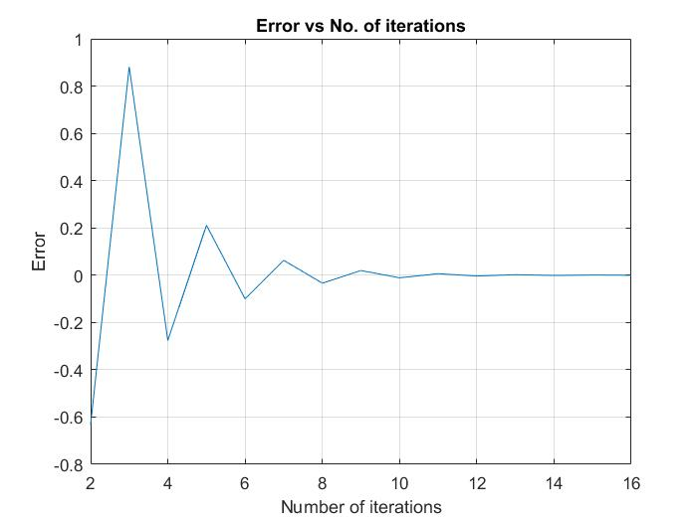

**4: Newton Raphson**

Point 1=0

Max number of iterations=50;

Criterion for Relative Error=0.0005

Criterion for closeness of function=0.00001

Root = 0.567143

Flag = Termination due to convergence of function value

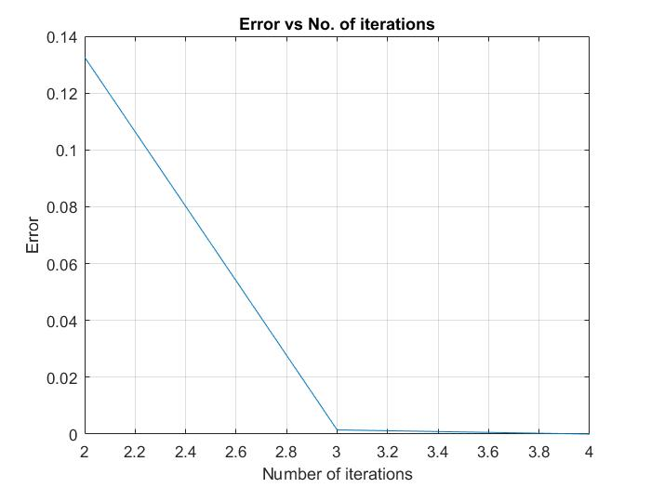

**5: Secant Method**

Point 1=0

Point 2=1

Max number of iterations=50;

Criterion for Relative Error=0.0005

Criterion for closeness of function=0.00001

Root = 0.567143

Flag = Termination due to convergence of function value

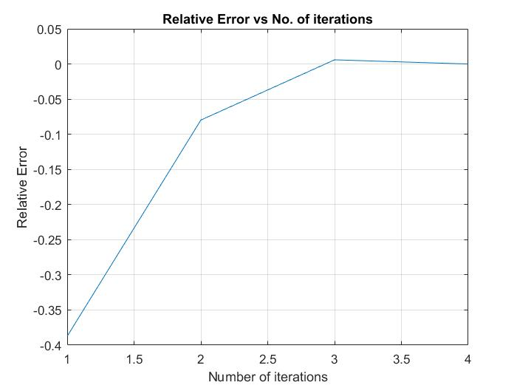

**Sample Function 3**: f(x) = x^4 − 7.4x^3 + 20.44x^2 − 24.184x + 9.6448 = 0

**Function Plot:**

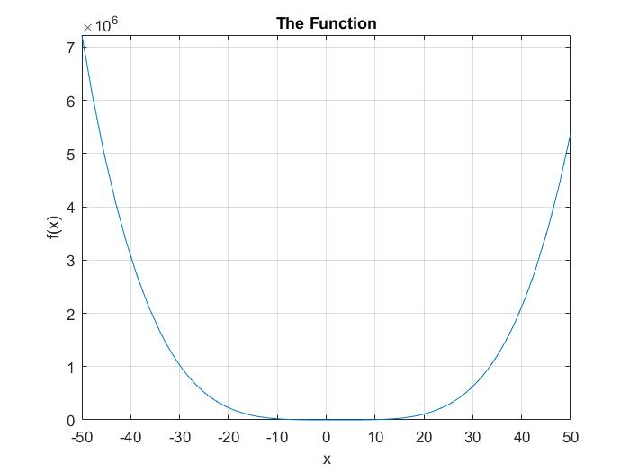

**1: Muller Method**

Point 1=-1;

Point 2=0;

Point 3=1;

Max number of iterations=50;

Criterion for Relative Error=0.0001

Criterion for closeness of function=0.00001

Root = 0.800000

Flag= Termination due to convergence of relative approximate error

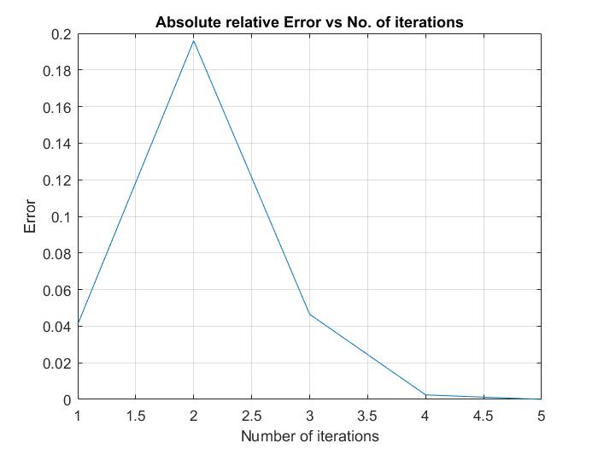

**2: Bairstow Method**

r=-5

s=4

Max number of iterations=50;

Criterion for Relative Error=0.0001

Criterion for closeness of function=0.00001

Roots = 2.2000+0.8000i

2.2000-0.8000i

Flag= Termination due to convergence of relative approximate error

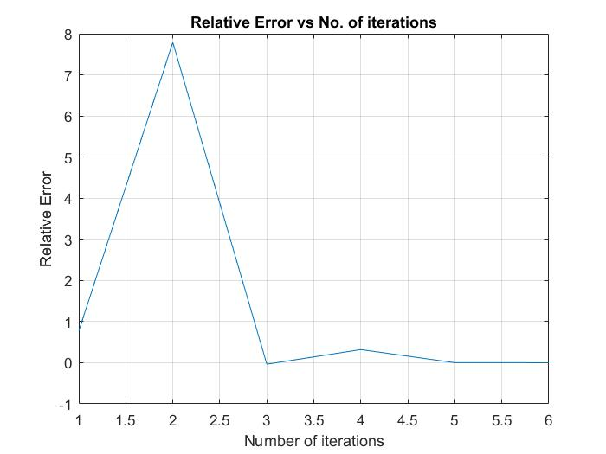

Relative Error vs Iteration curve for r

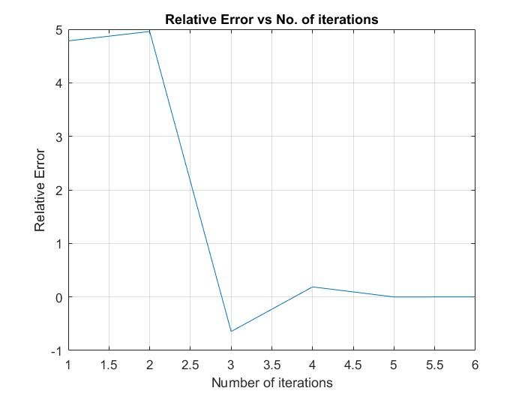

Relative Error vs Iteration curve for s

r=-2;

s=2;

Max number of iterations=50;

Criterion for Relative Error=0.0001

Criterion for closeness of function=0.00001

Roots= 2.2000 + 0.8000i 2.2000 - 0.8000i

2.2000 + 0.0000i 0.8000 + 0.0000i

Flag= Termination due to convergence of relative approximate error

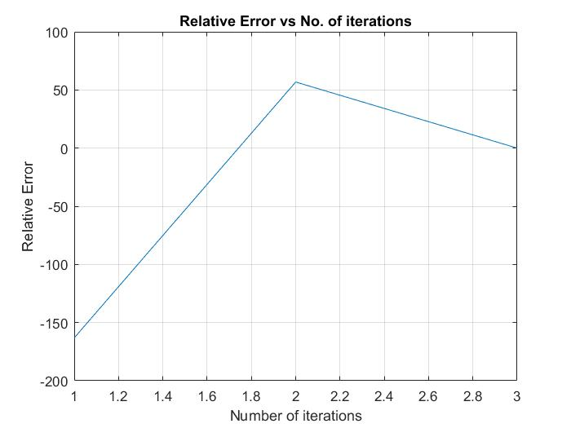

Relative Error vs Iteration curve for r

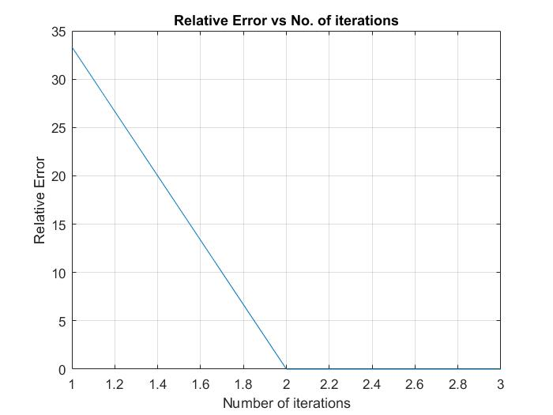

Relative Error vs Iteration curve for s